- Introduction
Learning Content
This learning unit shows how to pre-register. This is necessary to receive login data for the FST supplier portal.
Learning Targets
You can register initially in ordert o get login data for the FST supplier portal.
Prerequisites & Cross-References
none

- Recording area
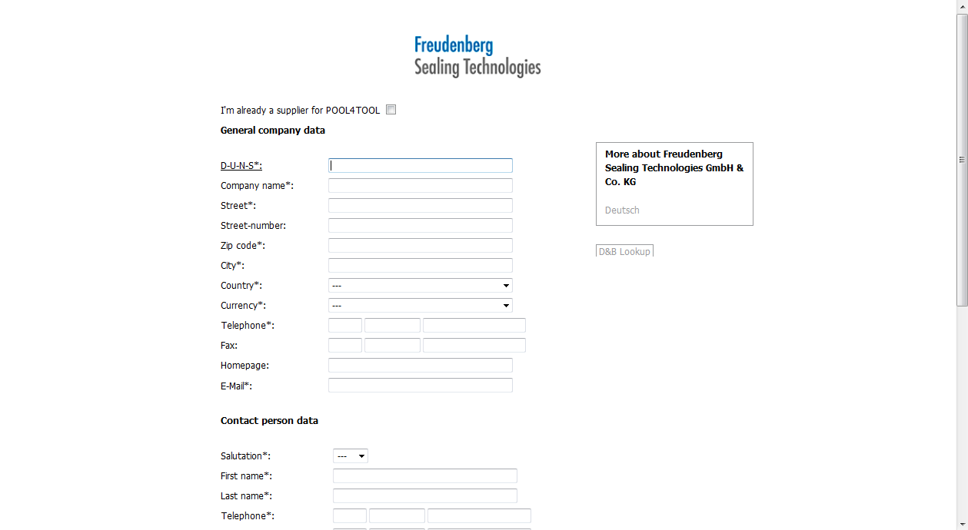
TIP: If you don’t have your DUNS number ready then use this button to determine it! Your address then will be entered automatically.
If you don’t know your DUNS number please enter your company name and the country of the registered office into the respective fields.
Click on „D&B Lookup“, then the major part of the fields will be filled in.
If you don’t have a DUNS number at all please click on DUNS Legal Entity and you will get to the UPIK-website where you can comfortably register for your DUNS number.

To get access to our FST Supplier Platform please pre-register!
https://fst.pool4tool.com/portal/fst/register.php

Please fill in all field marked with " * ".
After a successfull forwarding you will automatically receive an email with logon data.

Enter 9988776655 into the D-U-N-S field.
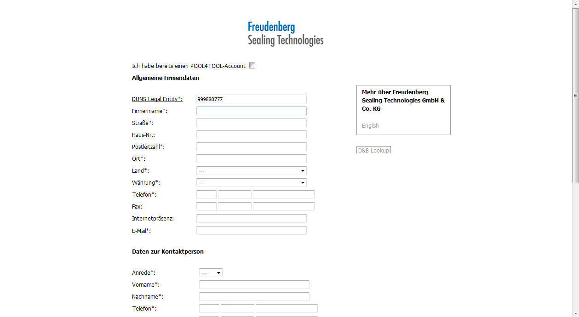
Press the 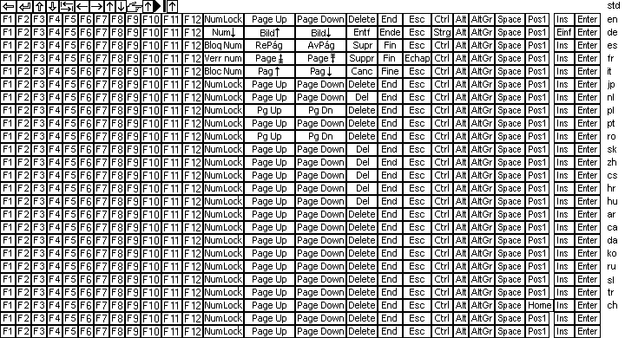 key.
Please enter all required data!

Click the vertical scroll bar.
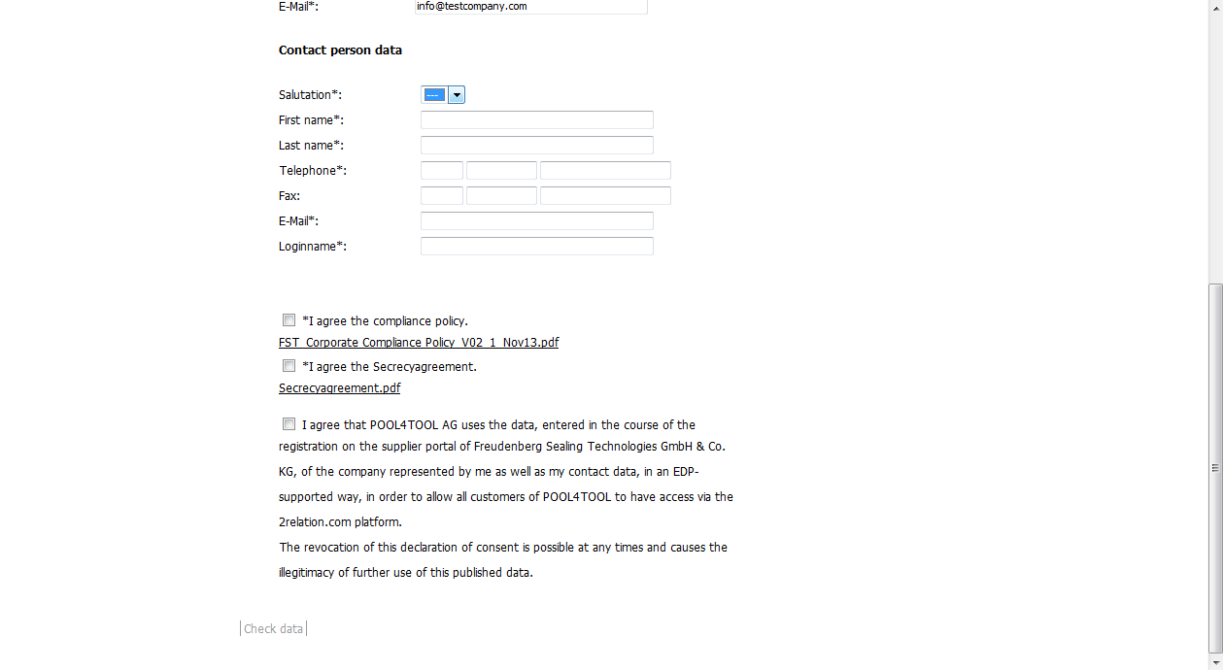
Click the (Salutation) dropdown button.
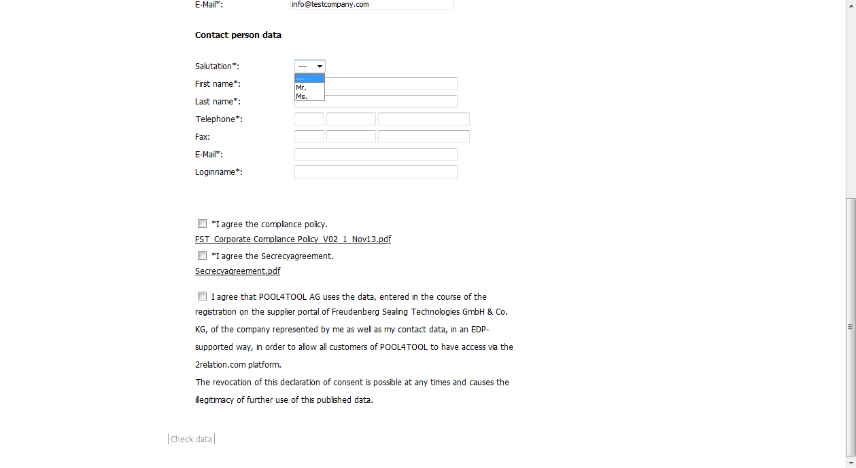
Click the Ms. list item.
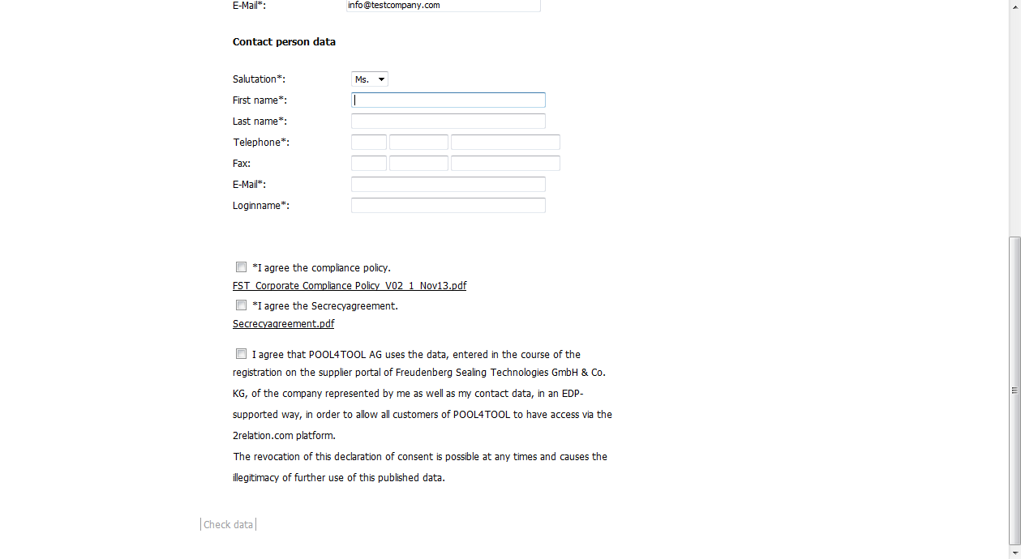
Enter Sandra into the First name field.
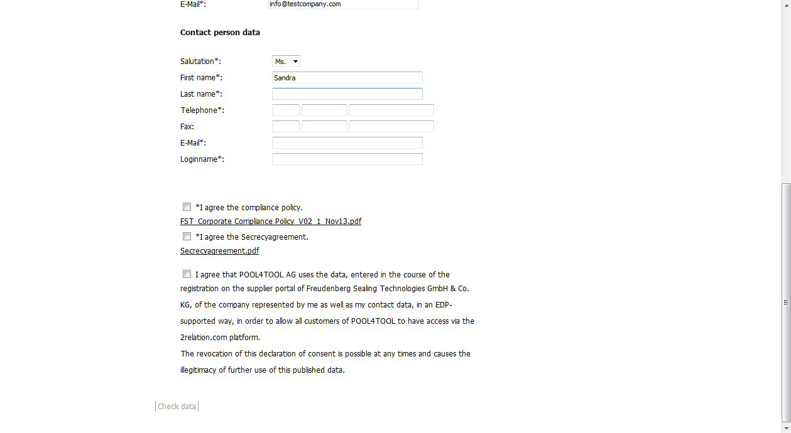
Press the key.
Enter Miller into the Last name field.
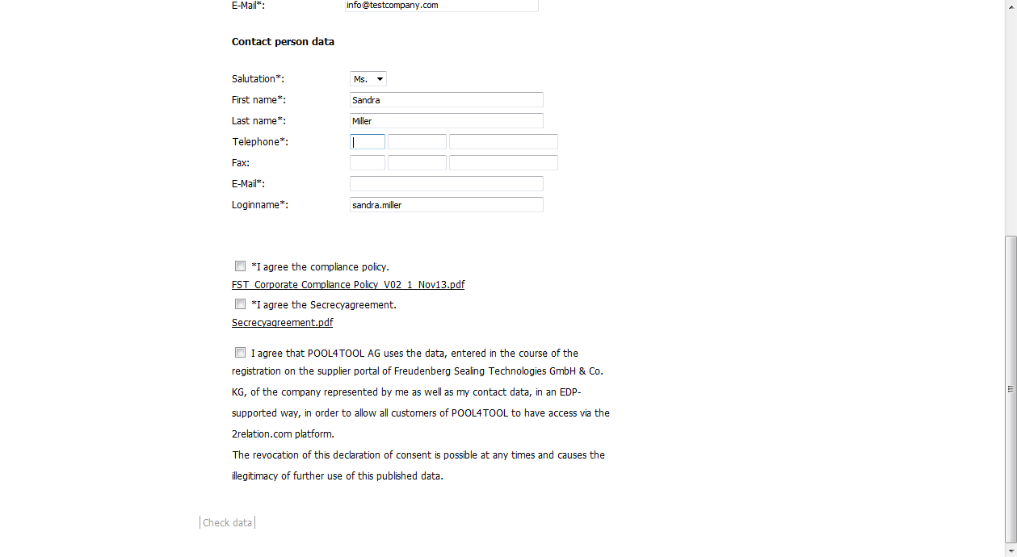
Press the key.
Enter 0049 into the Telephone field.
HINT:
The Login name (= user name) is automatically generated using the first and the last name.

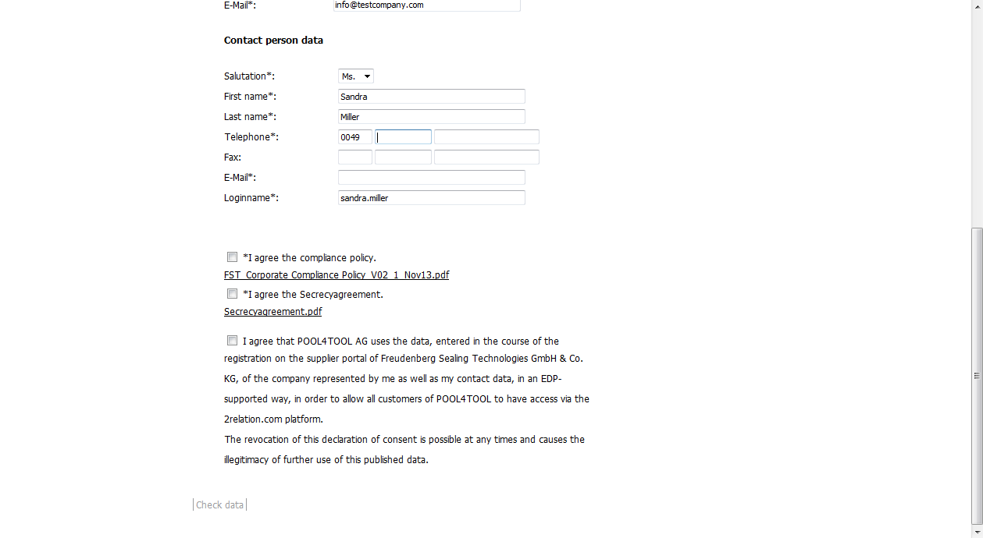
Press the key.
Enter 6201 into the Telephone field.
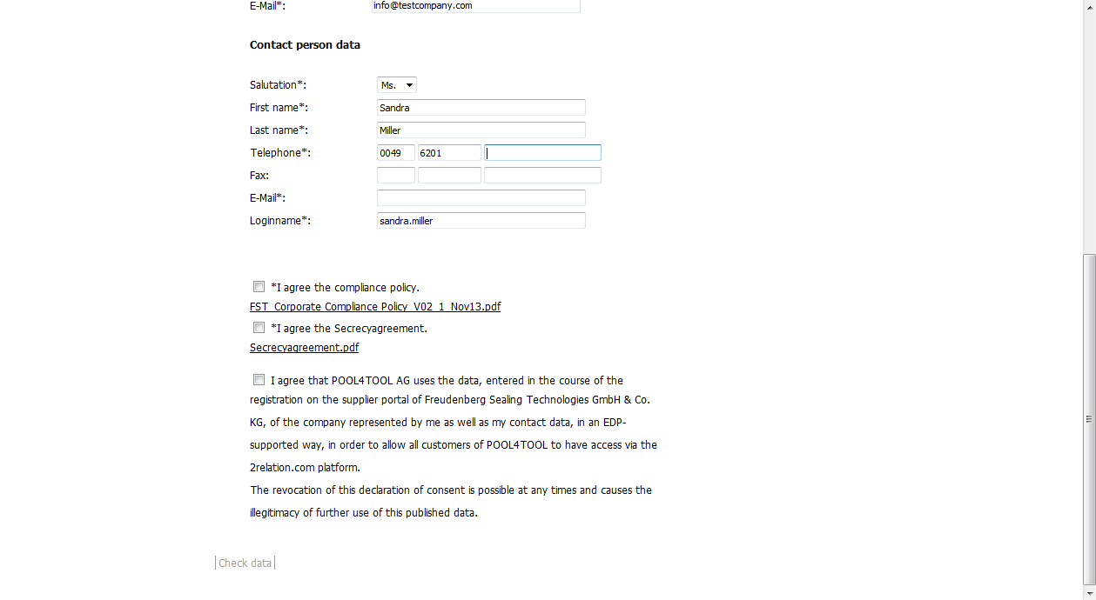
Press the key.
Enter 800 into the Telephone field.
Click the E-Mail input field.
Enter sandra@homann.de into the E-Mail field.
Click the FST_Corporate Compliance Policy PDF hyperlink.
HINT:
After a successful forwarding you will automatically receive an email to this mail address containing the logon data.

ATTENTION:
Please confirm both our compliance policy and the confidentiality agreement. You can display and print it via the assigned PDFs.
When registering finally you need to upload the signed versions!

Click the Öffnen (open) button.
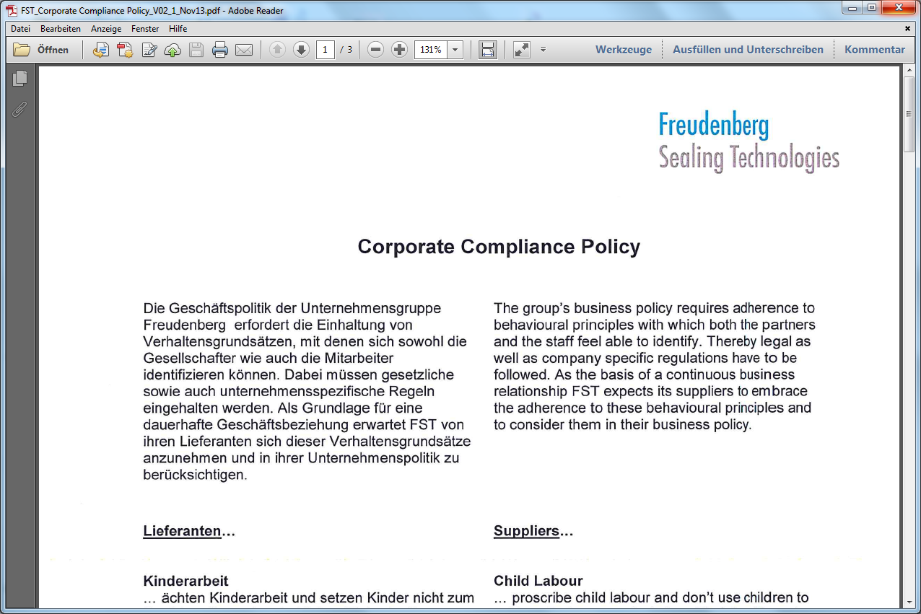
Click the Close button.
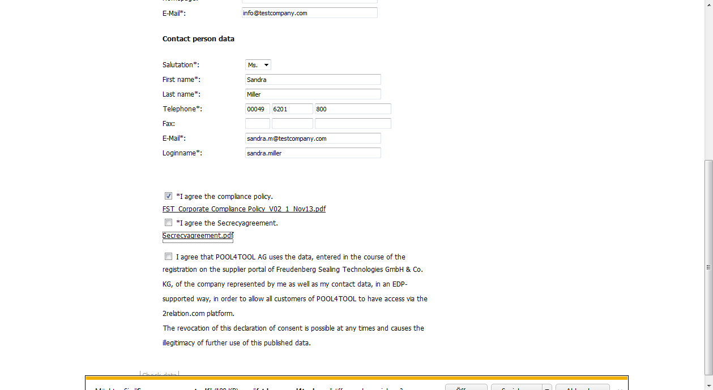
Click the compliance policy checkbox.
Click the Secrecyagreement.pdf hyperlink.
Click the Öffnen (open) button.
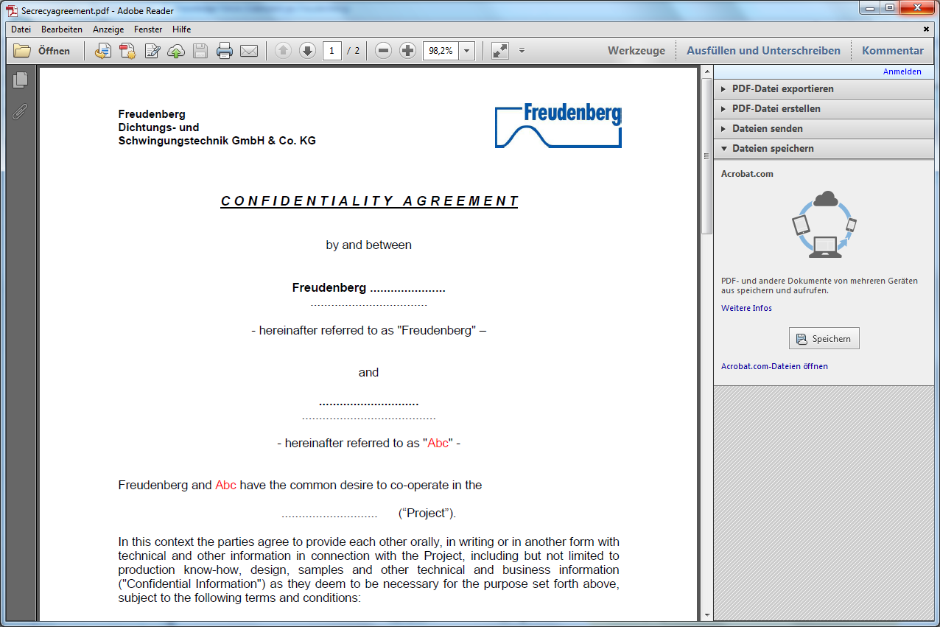
Click the Close button.
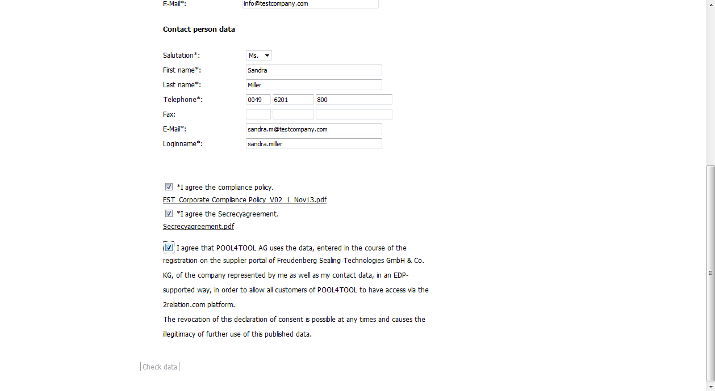
Click the Secrecy Agreement Policy checkbox.
Click the POOL4TOOL use checkbox.
Click the Check data hyperlink.
Check if all required entry fields are complete.

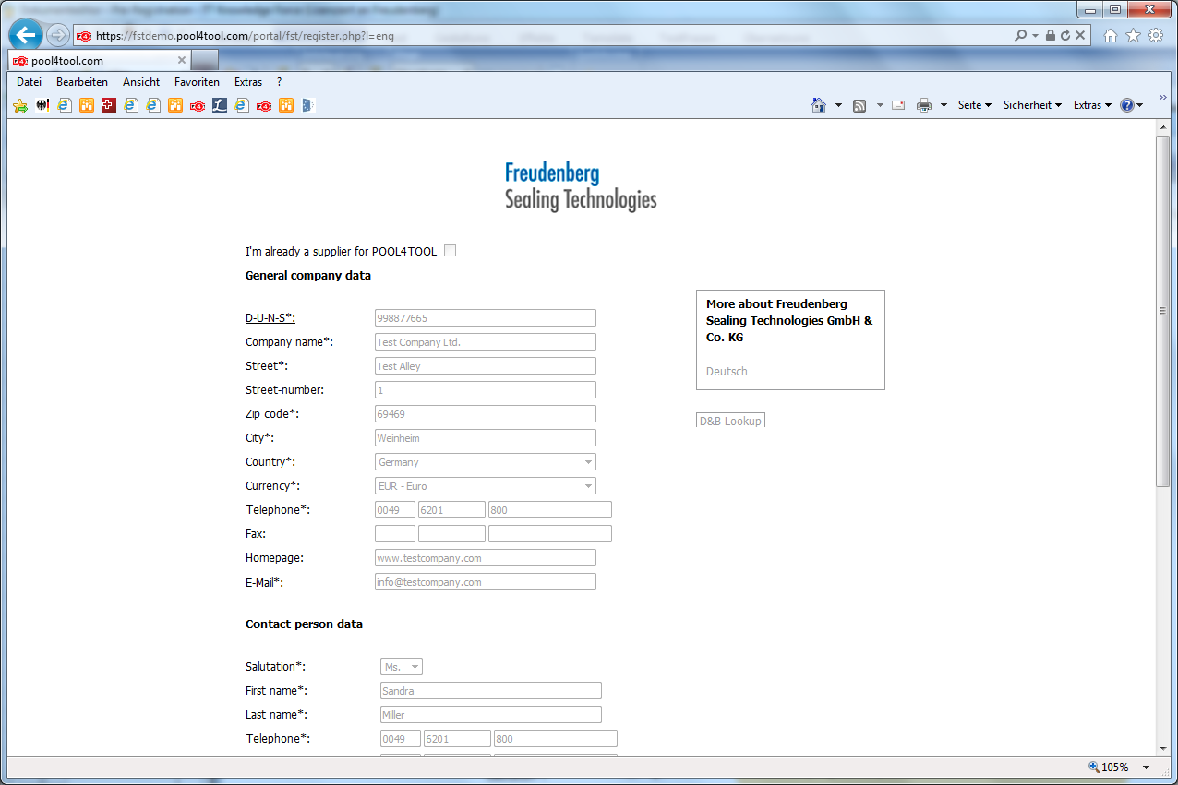
Click the vertical scroll bar.
If required entries were missing they would be marked.
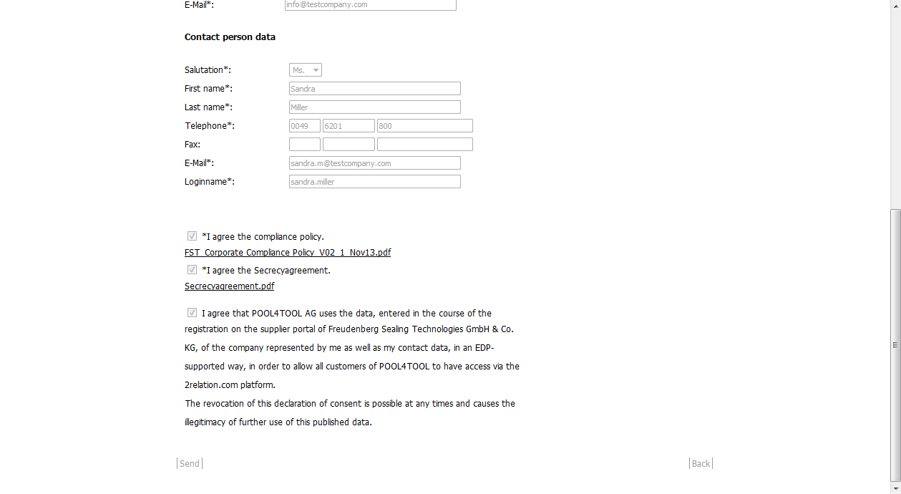
Click the Send hyperlink.
After all required entries are completed and checked there will be a button “SEND” which means that now you can forward your pre-registration to the FST purchasing department.

